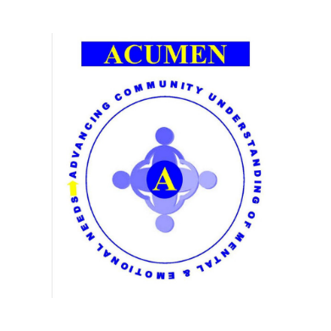

# You are invited to join the TAKE 5 CHALLENGE!

Throughout the month of March 2021ACUMEN Development Worker Sarah McFadzean is encouraging people in the Mid Argyll area to ‘Take 5’ for themselves to help boost mental and emotional wellbeing.

What’s Involved?

The Challenge is up to you! The idea is to bring some extra movement and fresh air into your daily routine. Choose an activity that suits your ability, some examples could be to take 5 minutes of fresh air each day, enjoy 5 deep breaths outdoors, walk for 5 minutes each day, or if you feel able to jog, run, cycle etc please do so! The main aim is to try to do your Take 5 activity each day in March. Please keep yourself safe.

Support

We have all been missing social interaction and while we may not be in a position to get together during this challenge, I hope we can use the dedicated Facebook Group to encourage, support and share our challenges.

Join here <https://www.facebook.com/groups/736076133707953>

Fund Raising

If you belong to a local Mid Argyll Group and would like to fund raise for them let them know! If you are a local group I’d be delighted if you used the Take 5 Challenge to fund raise for your group.

Contact: Please contact [sarah.mcfadzean@acumennetwork.org](mailto:sarah.mcfadzean@acumennetwork.org) with any queries or to express your interest.